DELHI TECHNOLOGICAL UNIVERSITY
Shahbad Daulatpur Village, Rohini, New Delhi, Delhi 110042



COMPUTER GRAPHICS
Lab File
(B1-G3)

SUBMITTED BY: SUBMITTED TO:
Ritik Singh Mr.Vinay dubey
2K19/CO/319

INDEX
S. No. | Name of Experiment | Experiment Date
1 | To write a program for implementing DDA Path Drawing Algorithm. | 27.8.2021
2 | To write a program for implementing Brensenham Path Drawing Algorithm. | 03.09.2021
3 | To write a program to implement the Mid-Point Circle Algorithm. | 10.09.2021
4 | To write a program to implement The Mid-Point Ellipse Algorithm. | 17.09.2021
5 | To write a program to implement the Circular Arc  Algorithm. | 24.09.2021
6 | To write a program to implement the Elliptical Arc Algorithm. | 24.09.2021
7 | To write a program to implement Flood Fill Algorithm. | 01.10.2021
8 | To write a program to implement Boundary Fill Algorithm | 01.10.2021
9 | To write a program to implement Cohen-Sutherland Line Clipping Algorithm. | 08.10.2021
10 | To write a program to implement a Thick Line. | 22.10.2021
11 | To write a Program to implement Liang-Barsky Line Clipping Algorithm. | 29.10.2021
12 | To write a Program to implement Rotation of an object. | 12.11.2021
13 | To write a Program to implement Scaling an Object. | 12.11.2021

EXPERIMENT-1

AIM: To write a program for implementing DDA Path drawing Algorithm.

THEORY:
The Digital differential analyzer (DDA) algorithm is an incremental scan-conversion method.
Such an approach is characterized by performing calculations at each step using results from the preceding step.

ALGORITHM:
Here (x1, y1) (x2, y2) are the end points and dx, dy are the float variables. Where dx= abs(x2-x1) and dy= abs(y2-y1)
- If dx >=dy then
length = dx
else
length = dy
endif
- dx = (x2-x1)/length
dy = (y2-y1)/length
- x = x1
y = y1
- i = 0
- Plot ((x), (y))
- x = x + dx
y = y + dy
- i = i + 1
- If i < length then go to step 5
- Stop

CODE:
#include<iostream>
#include <iomanip>
#include<cmath>
using namespace std;
int main(){
//Taken Input
double start_x=0, start_y=0, end_x=0, end_y=0;
double length = 0;
cout<<"Enter starting abscissa : (X) ";
cin>>start_x;
cout<<"Enter starting ordinate : (Y) ";
cin>>start_y;
cout<<"Enter ending abscissa : (X) ";
cin>>end_x;
cout<<"Enter ending ordinate : (Y) ";
cin>>end_y;
//Calculated dx and dy
double dx,dy;
dx = std::abs(end_x - start_x);
dy = std::abs(end_y - start_y);

//Conditionally calculated length
if(dx >= dy){
length = dx;
}
else{
length = dy;
}
dx = dx/length;
dy = dy/length;
int i = 0;
double current_point_x = start_x;
double current_point_y = start_y;

cout<<endl<<"X1\tY1\tX2\tY2\tL\tdx\tdy\ti\tx\ty\tresult\t"<<"\tplot"<<endl;
cout<<start_x<<"\t"<<start_y<<"\t"<<end_x<<"\t"<<end_y<<"\t"<<length<<"\t"<<setprecision(2)<<dx<<"\t"<<setprecision(2)<<dy<<"\t"<<i<<'\t'<<current_point_x<<'\t'<<current_point_y<<'\t'<<"("<<setprecision(2)<<current_point_x<<", "<<setprecision(2)<<current_point_y<<")"<<"\t\t"<<"("<<std::round(current_point_x)<<", "<<std::round(current_point_y)<<")"<<endl;
// looping till i < length
while(i<int(length)){
current_point_x = current_point_x + dx;
current_point_y = current_point_y + dy;
cout<<"\t"<<"\t"<<"\t"<<"\t"<<"\t"<<"\t"<<"\t"<<i+1<<"\t"<<setprecision(2)<<current_point_x<<'\t'<<setprecision(2)<<current_point_y<<'\t'<<"("<<setprecision(2)<<current_point_x<<", "<<setprecision(2)<<current_point_y<<")"<<"\t"<<"("<<std::round(current_point_x)<<", "<<std::round(current_point_y)<<")"<<endl;
i++;
}
}
OUTPUT:
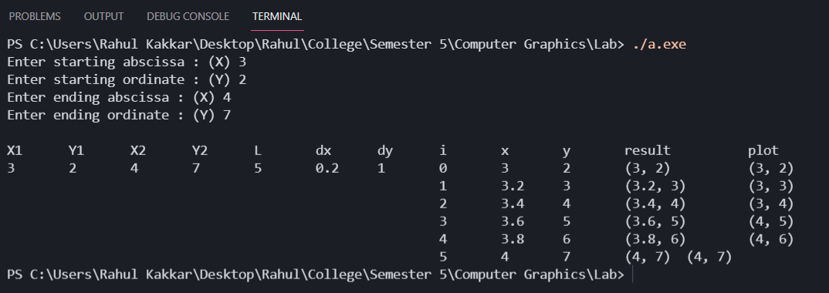
For Example: Starting (3,2) & Ending (4,7)

LEARNING OUTCOMES:
Through this, we got to know that how we can implement DDA line drawing Algorithm using C code.

EXPERIMENT-2

AIM: To write a program for implementing Brensenham Path drawing Algorithm.

THEORY:
Bresenham's line algorithm is a line drawing algorithm that determines the points of an n-dimensional raster that should be selected in order to form a close approximation to a straight line between two points.

ALGORITHM:
Here (x0, y0) (x1, y1) are the end points and dx, dy are the float variables. Where dx= abs(x2-x1) and dy= abs(y2-y1)
- plotLine(x0, y0, x1, y1)
- dx = x1 - x0
- dy = y1 - y0
- D = 2*dy - dx
- y = y0
- for x from x0 to x1
  - plot(x,y)
  - if D > 0
    - y = y + 1
    - D = D - 2*dx
  - end if
  - D = D + 2*dy

CODE:
#include <iostream.h>
#include <stdlib.h>
#include <maths.h>
#include <conio.h>
#include <stdio.h>
#include <graphics.h>

#include #include
/* Bresenham line-drawing procedure for |m| < 1.0. */
void lineBres (int x0, int y0, int xEnd, int yEnd)
{
int dx = fabs (xEnd - x0), dy = fabs(yEnd - y0);
int p = 2 * dy - dx;
int twoDy = 2 * dy, twoDyMinusDx = 2 * (dy - dx);
int x, y;

/* Determine which endpoint to use as start position. */
if (x0 > xEnd)
{
x = xEnd;
y = yEnd;
xEnd = x0;
}

else
{
x = x0;
y = y0;
}

setPixel (x, y);

while (x < xEnd)
{
x++;
if (p < 0)
p += twoDy;
else
{
y++;
p += twoDyMinusDx;
}
setPixel (x, y);
}
}

void main()
{
clrscr();
initgraph(&gd,&gm,"c:\\turboc3\\bgi");
float x1,y1;
cout<<"Enter starting and ending points to draw the line: ";
cin >> x0 >> y0 >> xEnd >> yEnd;
lineBres (int x0, int y0, int xEnd, int yEnd);
getch();
}

OUTPUT & RESULT:

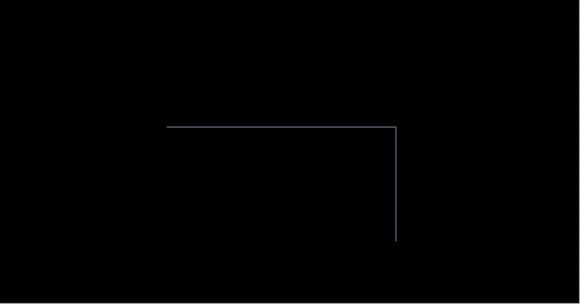

LEARNING OUTCOMES:
We got to know that how we can implement Brensenham Path drawing Algorithm.

EXPERIMENT-3
AIM: Write a program to implement the Mid-Point Circle Algorithm.

THEORY:
This algorithm is used in computer graphics to define the coordinates needed for rasterizing the circle. The midpoint circle drawing algorithm helps us to perform the generalization of conic sections. Bresenham’s circle drawing algorithm is also extracted from the midpoint circle drawing algorithm.
Advantages of Mid-Point Circle Algorithm:
- It is a powerful and efficient algorithm.
- The midpoint circle drawing algorithm is easy to implement.
- It is also an algorithm based on a simple circle equation (x² + y² = r²).
- This algorithm helps to create curves on a raster display.
Disadvantages of Mid-Point Circle Algorithm:
- It is a time-consuming algorithm.
- Sometimes the points of the circle are not accurate.
ALGORITHM:
Step-01:
Assign the starting point coordinates (X0, Y0) as
X0 = 0 Y0 = R
Step-02:
Calculate the value of initial decision parameter P0 as- P0 = 1 – R
Step-03:
Suppose the current point is (Xk, Yk) and the next point is (Xk+1, Yk+1).
Find the next point of the first octant depending on the value of decision parameter pk.
Step-04:
If the given centre point (X0, Y0) is not (0, 0), then do the following and plot the point Xplot = Xc + X0 Yplot = Yc + Y0
Here, (Xc, Yc) denotes the current value of X and Y coordinates.
Step-05:
Keep repeating Step-03 and Step-04 until Xplot >= Yplot.
Step-06:
Step-05 generates all the points for one octant.
To find the points for other seven octants, follow the eight symmetry property of the circle.
CODE:
# include <iostream>
# include <conio.h>
# include <graphics.h>
# include <math.h>
using namespace std;
void Circle(int Radius,int xC,int yC)
{
int P;
int x,y;
void Draw(int x,int y,int xC,int yC);
P = 1 - Radius;
x = 0;
y = Radius;
Draw(x,y,xC,yC);
while (x<=y)
{
x++;
if (P<0)
{
P += 2 * x + 1;
}
else
{
P += 2 * (x - y) + 1;
y--;
}
Draw(x,y,xC,yC);
}
}
void Draw(int x,int y,int xC,int yC)
{
putpixel(xC + x,yC + y,12);
putpixel(xC + x,yC - y,12);
putpixel(xC - x,yC + y,12);
putpixel(xC - x,yC - y,12);
putpixel(xC + y,yC + x,12);
putpixel(xC - y,yC + x,12);
putpixel(xC + y,yC - x,12);
putpixel(xC - y,yC - x,12);
}
int main()
{
int gDriver=DETECT, gMode;
initgraph(&gDriver,&gMode,"c:\\tc\\bgi"); int Radius, xC, yC;
cout<< endl << "Enter Center point coordinates...";
cout<<endl<<" Xc : ";
cin>>xC;
cout<<endl<<" Yc : ";
cin>>yC;
cout<<endl<<"Radius : ";
cin>>Radius;
cleardevice();
Circle(Radius,xC,yC);
getch();
return 0;
}
OUTPUT:
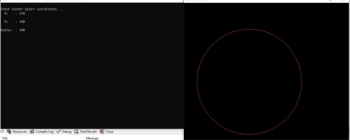

LEARNING OUTCOMES:
We got to know the implementation of the Mid-Point Circle Algorithm and also its advantages and disadvantages.

EXPERIMENT-4
AIM: Write a program to implement the Mid-Point Ellipse Algorithm.
THEORY:
The mid-point ellipse algorithm is an incremental method of drawing an ellipse. The mid-point ellipse drawing algorithm is used to calculate all the perimeter points of an ellipse. In this algorithm, the mid-point between the two pixels is calculated which helps in calculating the decision parameter. The value of the decision parameter determines whether the mid-point lies inside, outside, or on the ellipse boundary and the then position of the midpoint helps in drawing the ellipse.
Advantages:
● The mid-point ellipse algorithm has simple and easy implementation as it only includes additional operations.
Disadvantages:
● This algorithm is time consuming.
ALGORITHM:
1. Inputs: centre (xc,yc) and radius (rx,ry)
2. SET X=0 and Y=ry and p1 = ry^2 + (1/4)*(rx^2) - (rx^2)*ry
3. SET dx = 2*(ry^2)*X and dy = 2*(rx^2)*Y
4. Repeat While dx < dy
a) SET X=X+1
b) IF p1 < 0 , then SET p1 = p1 +2*(ry^2)*X + ry^2
c) Else, SET Y = Y-1 and p1 = p1 +2*(ry^2)*X - 2*(rx^2)*Y + ry^2
d) SET dx = 2*(ry^2)*X and dy = 2*(rx^2)*Y
e) Print pixel(X+xc , Y+yc)
f) Print pixel(-X+xc , Y+yc)
g) Print pixel(-X+xc , -Y+yc)
h) Print pixel(X+xc ,-Y+yc)
5. SET p2 = (ry^2)*(X+0.5)^2 + (rx^2)*(Y-1)^2 - (ry^2)*(rx^2)
6. Repeat while y >= 0
a) SET Y = Y-1
b) IF p2 < 0 , then SET X = X + 1 and p2 = p2 + 2*(ry^2)*X - 2*(rx^2)*Y+(rx^2) c) Else, SET p2 = p2 - 2*(rx^2)*Y + (rx^2)
d) Print pixel(X+xc , Y+yc)
e) Print pixel(-X+xc , Y+yc)
f) Print pixel(-X+xc , -Y+yc)
g) Print pixel(X+xc ,-Y+yc)
7. EXIT
CODE:
#include<iostream>
#include<graphics.h>
#include<stdlib.h>
#include<conio.h>
using namespace std;
int main()
{
int gd = DETECT, gm;
int xc,yc,x,y;
float p;
long rx,ry;
initgraph(&gd, &gm, "C:\\TC\\BGI");
cout<<"Enter coordinates of centre : ";
cin>>xc>>yc;
cout<<"Enter x,y radius of ellipse: ";
cin>>rx>>ry;
p=ry*ry-rx*rx*ry+rx*rx/4;
x=0;y=ry;
while(2.0*ry*ry*x <= 2.0*rx*rx*y)
{
if(p < 0)
{
x++;
p = p+2*ry*ry*x+ry*ry;
}
else
{
x++;y--;
p = p+2*ry*ry*x-2*rx*rx*y-ry*ry;
}
putpixel(xc+x,yc+y,RED);
putpixel(xc+x,yc-y,RED);
putpixel(xc-x,yc+y,RED);
putpixel(xc-x,yc-y,RED);
}
//Region 2
p=ry*ry*(x+0.5)*(x+0.5)+rx*rx*(y-1)*(y-1)-rx*rx*ry*ry; while(y > 0)
{
if(p <= 0)
{
x++;y--;
p = p+2*ry*ry*x-2*rx*rx*y+rx*rx;
}
else
{
y--;
p = p-2*rx*rx*y+rx*rx;
}
putpixel(xc+x,yc+y,RED);
putpixel(xc+x,yc-y,RED);
putpixel(xc-x,yc+y,RED);
putpixel(xc-x,yc-y,RED);
}
getch();
closegraph();
return 0;
}
OUTPUT:
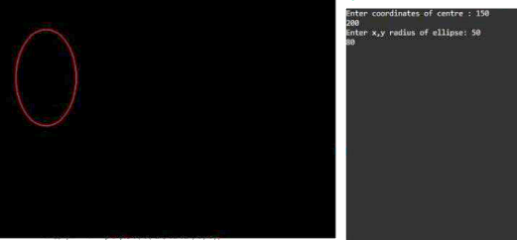

LEARNING OUTCOMES:
We got to know the implementation of the Mid-Point Ellipse Algorithm and also its advantages and disadvantages.

EXPERIMENT-5
AIM: Write a program to implement the Circular Arc algorithm.
THEORY:
The Circular Arc algorithm is similar to the circle algorithm. It takes input as the center of the circle , radius of circle and arc’s starting and ending angle. This algorithm then obtain points through finding the sin and cos radian at each angle between starting and ending angle. This algorithm is used to generate curves on raster displays. It is easy to implement from the programmer’s perspective.
ALGORITHM:
1. Inputs: centre (x_cen,y_cen) and radius (rad) and (start_ang, end_ang)
2. IF (start_ang <= end_ang), then SET ang = start_ang*(PI/180)
3. Else, SET ang = end_ang*(PI/180)
4. IF (start_ang < end_ang), then SET range = start_ang*(PI/180)
5. Else, SET range = end_ang*(PI/180)
6. SET x = rad*cos(ang)
7. SET y = rad*sin(ang)
8. Repeat While ang <= range
a. Print pixel(x_cen+x+0.5 , y_cen-y+0.5)
b. SET ang = ang + 0.001
c. SET x = rad*cos(ang)
d. SET y = rad*sin(ang)
9. EXIT
CODE:
#include<iostream>
#include<graphics.h>
#include<math.h>
using namespace std;
#define PI 3.141592
void Cir_arc(const int x_cen,const int y_cen,const int rad, const int start_ang,const int end_ang)
{
float ang=(((start_ang<=end_ang)?start_ang:end_ang)*(PI/180)); float range=(((end_ang>start_ang)?end_ang:start_ang)*(PI/180)); float x=(rad*cos(ang));
float y=(rad*sin(ang));
do
{
putpixel((int)(x_cen+x+0.5),(int)(y_cen-y+0.5),CYAN);
ang+=0.001;
x=(rad*cos(ang));
y=(rad*sin(ang));
}
while(ang<=range);
}
int main(){
int x_cen,y_cen,rad,start_ang,end_ang;
cout<<"Enter centre's x_coordinate:";
cin>>x_cen;
cout<<"Enter centre's y_coordinate:";
cin>>y_cen;
cout<<"Enter radius of arc:";
cin>>rad;
cout<<"Enter start angle of arc:";
cin>>start_ang;
cout<<"Enter end angle of arc:";
cin>>end_ang;
int gd=DETECT,gm;
initgraph(&gd,&gm,"");
Cir_arc(x_cen,y_cen,rad,start_ang,end_ang);
getch();
closegraph();
return 0;
}
OUTPUT:

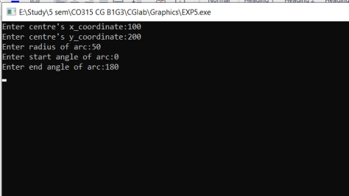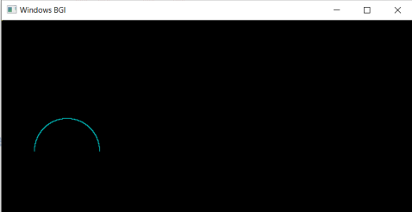

LEARNING OUTCOMES:
We have successfully implemented the Circular Arc algorithm. We also learn about the graphics.h header file.

EXPERIMENT-6
AIM: Write a program to implement the Elliptical Arc algorithm.
THEORY:
The Elliptical Arc algorithm is similar to the circular arc algorithm. It takes input as the center of the ellipse , x-radius and y-radius of the ellipse and arc’s starting and ending angle. This algorithm then obtains points through finding the sin and cos radian at each angle between starting and ending angle. This algorithm is used to generate curves on raster displays. It is easy to implement from the programmer’s perspective.
ALGORITHM:
1. Inputs: centre (x_cen,y_cen) and radius (xrad,yrad) and (start_ang,end_ang)
2. IF (start_ang <= end_ang), then SET ang = start_ang*(PI/180)
3. Else, SET ang = end_ang*(PI/180)
4. IF (start_ang < end_ang), then SET range = start_ang*(PI/180)
5. Else, SET range = end_ang*(PI/180)
6. SET x = xrad*cos(ang)
7. SET y = yrad*sin(ang)
8. Repeat While ang <= range
a. Print pixel(x_cen+x+0.5 , y_cen-y+0.5)
b. SET ang = ang + 0.001
c. SET x = xrad*cos(ang)
d. SET y = yrad*sin(ang)
9. EXIT
CODE:
#include<iostream>
#include<graphics.h>
#include<math.h>
using namespace std;
#define PI 3.141592
void Elli_arc(int xcen,int ycen,int xrad,int yrad,int start_ang,int end_ang) {
float ang=(((start_ang<=end_ang)?start_ang:end_ang)*(PI/180)); float range=(((end_ang>start_ang)?end_ang:start_ang)*(PI/180)); float x=(xrad*cos(ang));
float y=(yrad*sin(ang));
do
{
putpixel((int)(xcen+x+0.5),(int)(ycen-y+0.5),CYAN);
ang+=0.001;
x=(xrad*cos(ang));
y=(yrad*sin(ang));
}
while(ang<=range);
}
int main(){
int x_cen,y_cen,xrad,yrad,start_ang,end_ang;
cout<<"Enter centre's x_coordinate:";
cin>>x_cen;
cout<<"Enter centre's y_coordinate:";
cin>>y_cen;
cout<<"Enter x_radius of arc:";
cin>>xrad;
cout<<"Enter y_radius of arc:";
cin>>yrad;
cout<<"Enter start angle of arc:";
cin>>start_ang;
cout<<"Enter end angle of arc:";
cin>>end_ang;
int gd=DETECT,gm;
initgraph(&gd,&gm,"");
Elli_arc(x_cen,y_cen,xrad,yrad,start_ang,end_ang);
getch();
return 0;
}
OUTPUT:

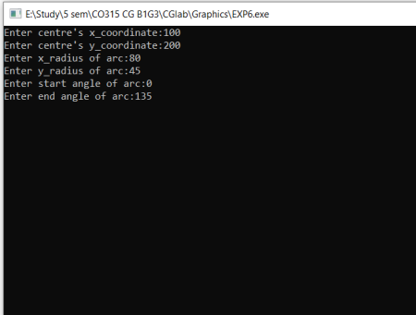
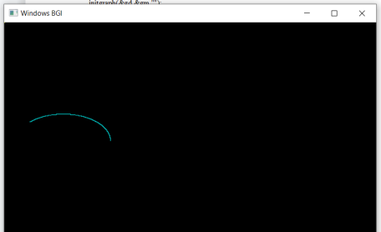

LEARNING OUTCOMES:
We have successfully implemented the Elliptical Arc algorithm. We also learn about the graphics.h header file.

EXPERIMENT-7
AIM: Write a program to implement flood fill algorithm.

THEORY:
In this method, a point or seed which is inside the region is selected. This point is called a seed point. Then four connected approaches or eight connected approaches are used to fill with specified color.
The flood fill algorithm has many characters similar to boundary fill. But this method is more suitable for filling multiple colors boundaries. When the boundary is of many colors and the interior is to be filled with one color we use this algorithm.

ALGORITHM:
Flood( x,y, newclr ,oldclr) :
1. IF getpixel(x,y)==oldclr, then
a) Print pixel (x,y,newclr)
b) Flood( x+1,y, newclr ,oldclr)
c) Flood( x-1,y, newclr ,oldclr)
d) Flood( x,y+1, newclr ,oldclr)
e) Flood( x,y-1, newclr ,oldclr)
2. EXIT

CODE:
#include<iostream>
#include<graphics.h>
#include<dos.h>
using namespace std;
void floodFill(int x,int y,int oldcolor,int newcolor) {
if(getpixel(x,y) == oldcolor)
{
putpixel(x,y,newcolor);
floodFill(x+1,y,oldcolor,newcolor);
floodFill(x,y+1,oldcolor,newcolor);
floodFill(x-1,y,oldcolor,newcolor);
floodFill(x,y-1,oldcolor,newcolor);
}
}
//getpixel(x,y) gives the color of specified pixel
int main()
{
int gm,gd=DETECT,radius;
int x,y;
cout<<"Enter x and y positions for circle\n";
cin>>x>>y;
cout<<"Enter radius of circle\n";
cin>>radius;
initgraph(&gd,&gm,"c:\\turboc3\\bgi");
circle(x,y,radius);
floodFill(x,y,0,15);
delay(5000);
closegraph();
return 0;
}
OUTPUT:

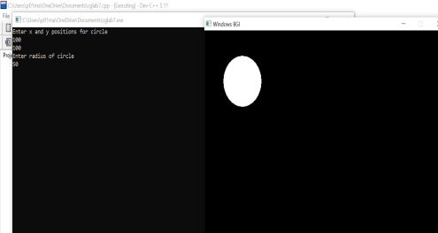

LEARNING OUTCOMES:
We got to know the implementation of flood fill algorithm using a C++ code.

EXPERIMENT-8

AIM: Write a program to implement boundary fill algorithm.
THEORY:
Boundary Fill algorithm is used to fill the inside of a closed polygon having a boundary of the same color with a desired color. It is mainly used with interactive-painting packages where an inside point can be easily chosen as its approach requires a starting pixel also called seed, to start with. It is mainly implemented using stack-based recursion. Functioning of the boundary-fill requires an interior point (x,y) , fill color and boundary color to start with. The algorithm starts by checking whether a pixel value equals boundary color or fill color . If not, the pixel is filled with the desired color and advances to check for neighboring pixels. Else, not. The process continues until it hits all sides of the boundary region.
ALGORITHM:
Boundary( x,y, fillclr, boundaryclr) :
1. IF getpixel(x,y)!=fillclr AND getpixel(x,y)!=boundaryclr, then
a) Print pixel (x,y,fillclr)
b) Boundary( x+1,y, fillclr, boundaryclr)
c) Boundary( x-1,y, fillclr, boundaryclr)
d) Boundary( x,y+1, fillclr, boundaryclr)
e) Boundary( x,y-1, fillclr, boundaryclr)
2. EXIT
CODE:
//including header files
#include <iostream>
#include <conio.h>
#include <graphics.h>
#include <dos.h>
using namespace std;
void bfill(int x,int y,int fill,int border)
{
if((getpixel(x,y)!=border)&&(getpixel(x,y)!=fill)) {
delay(8);
putpixel(x,y,fill);
bfill(x+1, y,fill,border);
bfill(x, y+1,fill,border);
bfill(x-1, y,fill,border);
bfill(x, y-1,fill,border);
}
}
int main()
{
int gd=DETECT,gm;
initgraph(&gd,&gm,"C:\\Tc\\BGI"); rectangle(10,50,50,10);
bfill(11,12,MAGENTA,WHITE); getch();
closegraph();
return 0; }

OUTPUT:
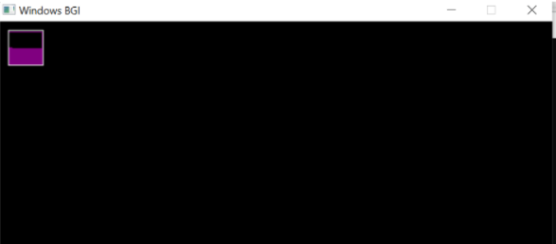

LEARNING OUTCOMES:
We got to know the implementation of the boundary fill algorithm using a C++ code.

EXPERIMENT-9
AIM: Write a program to implement Cohen-Sutherland line clipping algorithm.
THEORY:
This is one of the oldest and most popular line clipping algorithm. The algorithm divides the 2D space into 9 regions and efficiently determines the portion of line visible in the viewport. To speed up the process this algorithm performs initial tests that reduce the number of intersections that must be calculated. It does so by using a 4 bit code called region code or outcodes. These codes identify the location of the end point of line.
Each bit position indicates a direction, starting from the rightmost position of each bit indicates left, right, bottom, top respectively.
Once we establish region codes for both the endpoints of a line we determine whether the endpoint is visible, partially visible or invisible with the help of ANDing of the region codes.
ALGORITHM:
- Read 2 end points of line as p1(x1, y1) and p2(x2, y2)
- Read 2 corner points of the clipping window (left-top and right-bottom) as (wx1, wy1) and (wx2, wy2)
- Assign the region codes for 2 endpoints p1 and p2 using following steps: - Initialize code with 0000
  - Set bit 1 if x<wx1
  - Set bit 2 if x>wx2
  - Set bit 3 if y<wy2
  - Set bit 4 if y>wy1
- Check for visibility of line
  - If region codes for both endpoints are zero then the line is completely visible. Draw the line go to step 9.
  - If region codes for endpoints are not zero and logical ANDing of them is also nonzero then the line is invisible. Discard the line and move to step 9.
  - If it does not satisfy 4.a and 4.b then the line is partially visible.
- Determine the intersecting edge of clipping window as follows: -
  - If region codes for both endpoints are nonzero, find intersection points p1’ and p2’ with boundary edges.
  - If the region code for any one end point is non zero then find intersection point p1’ or p2’.
- Divide the line segments considering intersection points.
- Reject line segment if any end point of line appears outside of any boundary.
- Draw the clipped line segment.
- Stop.
CODE:
#include<iostream>
#include<stdlib.h>
#include<math.h>
#include<graphics.h>
#include<dos.h>
using namespace std;
typedef struct coordinate
{
int x,y;
char code[4];
}PT;
void drawwindow()
{
line(150,100,450,100);
line(450,100,450,350);
line(450,350,150,350);
line(150,350,150,100);
}
void drawline(PT p1,PT p2) {
line(p1.x,p1.y,p2.x,p2.y); }
PT setcode(PT p)
{
PT ptemp;
if(p.y<100) ptemp.code[0]='1'; else ptemp.code[0]='0';
if(p.y>350) ptemp.code[1]='1'; else ptemp.code[1]='0';
if(p.x>450) ptemp.code[2]='1'; else ptemp.code[2]='0';
if(p.x<150) ptemp.code[3]='1';
else ptemp.code[3]='0';
ptemp.x=p.x;
ptemp.y=p.y;
return(ptemp);
}
int visibility(PT p1,PT p2)
{
int i,flag=0;
for(i=0;i<4;i++)
{
if((p1.code[i]!='0') || (p2.code[i]!='0')) flag=1;
}
if(flag==0) return(0);
for(i=0;i<4;i++)
{
if((p1.code[i]==p2.code[i]) && (p1.code[i]=='1')) flag='0'; }
if(flag==0) return(1);
return(2);
}
PT resetendpt(PT p1,PT p2)
{
PT temp;
int x,y,i;
float m,k;
if(p1.code[3]=='1') x=150;
if(p1.code[2]=='1') x=450;
if((p1.code[3]=='1') || (p1.code[2]=='1')) {
m=(float)(p2.y-p1.y)/(p2.x-p1.x); k=(p1.y+(m*(x-p1.x)));
temp.y=k;
temp.x=x;
for(i=0;i<4;i++)
temp.code[i]=p1.code[i];
if(temp.y<=350 && temp.y>=100) return (temp);
}
if(p1.code[0]=='1') y=100;
if(p1.code[1]=='1') y=350;
if((p1.code[0]=='1') || (p1.code[1]=='1')) {
m=(float)(p2.y-p1.y)/(p2.x-p1.x); k=(float)p1.x+(float)(y-p1.y)/m; temp.x=k;
temp.y=y;
for(i=0;i<4;i++)
temp.code[i]=p1.code[i];
return(temp);
}
else return(p1);
}
int main()
{
int gd=DETECT,v,gm;
PT p1,p2,p3,p4,ptemp;
cout<<"\nEnter x1 and y1\n";
cin>>p1.x>>p1.y;
cout<<"\nEnter x2 and y2\n";
cin>>p2.x>>p2.y;
initgraph(&gd,&gm,"c:\\turboc3\\bgi"); drawwindow();
delay(500);
drawline(p1,p2);
delay(500);
cleardevice();
delay(500);
p1=setcode(p1);
p2=setcode(p2);
v=visibility(p1,p2);
delay(500);
switch(v)
{
case 0:
{
drawwindow();
delay(500);
drawline(p1,p2);
break;
}
case 1:
{
drawwindow();
delay(500);
break;
}
case 2:
{
p3=resetendpt(p1,p2); p4=resetendpt(p2,p1); drawwindow();
delay(500);
drawline(p3,p4);
break;
}
}
delay(5000);
closegraph();
return 0;
}
OUTPUT:
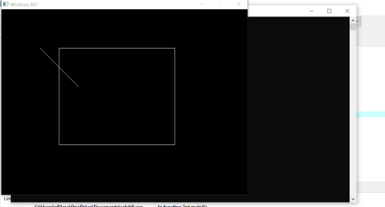

LEARNING OUTCOMES:
We got to know the implementation of Cohen-Sutherland line clipping algorithm using a C++ code.

EXPERIMENT-10
AIM: Write a program to implement a thick line.
THEORY:
A thick line, accordingly, is represented as a composite of two or more parallel and adjacent single pixel lines.
The Bresenham algorithm is an incremental scan conversion algorithm.
The big advantage of this algorithm is that it uses only integer calculations. Moving across the x axis in unit intervals and at each step choose between two different y coordinates.
It has following various types:
- SOLID LINE
- DOTTED LINE
- DASHED LINE
- THICK LINE
ALGORITHM:
  - Inputs: starting point (x1,y1) and end point (x2,y2)
  - SET dx = abs(x2-x1) & dy = abs(y2-y1)
  - IF x1<x2, then SET xinc = 1
  - ELSE , SET xinc = -1
  - IF y1<y2, then SET yinc = 1
  - ELSE , SET yinc = -1
  - SET X = x1 & Y = y1
  - Print pixel(X,Y)
  - IF dx >= dy, then
    - SET e = 2*dy - dx
    - Repeat While X != x2
    - IF e < 0, then SET e = e + 2*dy
    - ELSE , then
      - SET e = e + 2*dx - 2*dy
      - SET Y = Y+yinc
    - SET X=X+ xinc
    - Print pixel(X,Y)
  - ELSE, then
    - SET e = 2*dx - dy
    - Repeat While Y != y2
    - IF e < 0, then SET e = e + 2*dx
    - ELSE , then
      - SET e = e + 2*dy - 2*dx
      - SET X = X+xinc
    - SET Y=Y+ yinc
    - Print pixel(X,Y)
  - EXIT
ThicknessAlgo( x1, y1, x2, y2) :
1. bline(x1, x2, y1, y2)
2. IF (y2-y1)/(x2-x1) < 0, then
a) SET
wy=(thickness-1)*sqrt(pow((x2-x1),2)+pow((y2-y1),2))/(2*fabs(x2-x1)) b) Repeat for I = 0 to I < wy:
i. bline(x1,y1-i,x2,y2-i)
ii. bline(x1,y1+i,x2,y2+i);
iii. SET I = I +1
3. ELSE , then
a) SET
wx=(thickness-1)*sqrt(pow((x2-x1),2)+pow((y2-y1),2))/(2*fabs(y2-y1)) b) Repeat for I = 0 to I < wy:
i. bline(x1-i,y1,x2-i,y2)
ii. bline(x1+i,y1,x2+i,y2);
iii. SET I = I +1
4. EXIT
CODE:
#include<stdio.h>
#include<graphics.h>
#include<math.h>
void bline(float x1,float y1,float x2,float y2);
void main()
{
int gd=DETECT,gm;
float wy,wx,x1,y1,x2,y2;
int i,thickness;
initgraph(&gd,&gm,"");
printf("Enter x1,y1,x2,y2:\n");
scanf("%f%f%f%f",&x1,&y1,&x2,&y2);
printf("\nEnter thickness of line: ");
scanf("%d",&thickness);
bline(x1,y1,x2,y2);
if((y2-y1)/(x2-x1)<1)
{
wy=(thickness-1)*sqrt(pow((x2-x1),2)+pow((y2-y1),2))/(2*fabs(x2-x1)); for(i=0;i<wy;i++)
{
bline(x1,y1-i,x2,y2-i);
bline(x1,y1+i,x2,y2+i);
}
}
else
{
wx=(thickness-1)*sqrt(pow((x2-x1),2)+pow((y2-y1),2))/(2*fabs(y2-y1)); for(i=0;i<wx;i++)
{
bline(x1-i,y1,x2-i,y2);
bline(x1+i,y1,x2+i,y2);
}
}
getch();
closegraph();
restorecrtmode();
}
void bline(float x1,float y1,float x2,float y2)
{
float xinc,yinc,x,y;
float dx,dy,e;
dx=abs(x2-x1);
dy=abs(y2-y1);
if(x1<x2) xinc=1;
else xinc=-1;
if(y1<y2) yinc=1;
else yinc=-1;
x=x1;
y=y1;
putpixel(x,y,WHITE); if(dx>=dy)
{
e=(2*dy)-dx;
while(x!=x2)
{
if(e<0)
{
e+=(2*dy);
}
else
{
e+=(2*(dy-dx));
y+=yinc;
}
x+=xinc;
putpixel(x,y,WHITE);
}
}
else
{
e=(2*dx)-dy;
while(y!=y2)
{
if(e<0)
{
e+=(2*dx);
}
else
{
e+=(2*(dx-dy));
x+=xinc;
}
y+=yinc;
putpixel(x,y,WHITE);
}
}
}

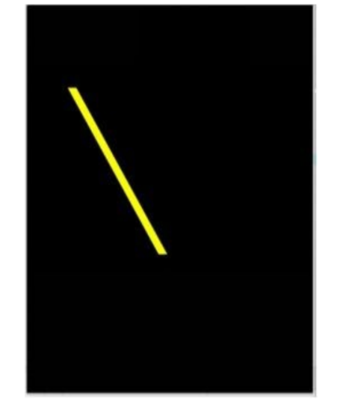
OUTPUT:
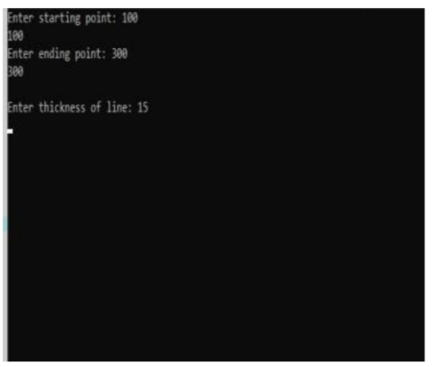

LEARNING OUTCOMES:
We got to know the implementation of a thick line using a C code.

EXPERIMENT 11
AIM: Write a Program to implement Liang-Barsky line clipping algorithm.
THEORY:
The Liang-Barsky algorithm is a line clipping algorithm. This algorithm is more efficient than Cohen–Sutherland line clipping algorithm and can be extended to 3-Dimensional clipping. This algorithm is considered to be the faster parametric line-clipping algorithm.
The following concepts are used in this clipping:
- The parametric equation of the line.
- The inequalities describing the range of the clipping window which is used to determine the intersections between the line and the clip window.
ALGORITHM:
- Set tmin=0, tmax=1.
- Calculate the values of t (t(left), t(right), t(top), t(bottom)),
  - If t < tmin ignore that and move to the next edge.
  - else separate the t values as entering or exiting values using the inner product.
  - If t is entering value, set tmin = t; if t is existing value, set tmax = t.
- If tmin < tmax, draw a line from (x1 + tmin(x2-x1), y1 + tmin(y2-y1)) to (x1 + tmax(x2-x1), y1 + tmax(y2-y1))
- If the line crosses over the window, (x1 + tmin(x2-x1), y1 + tmin(y2-y1)) and (x1 + tmax(x2-x1), y1 + tmax(y2-y1)) are the intersection point of line and edge.

CODE:

#include<iostream.h>
#include<conio.h>
#include<graphics.h>
void main()
{
int gd=DETECT,gm;
initgraph(&gd,&gm,"C:\\TC\\BGI");
int x1,y1,x2,y2,xmax,xmin,ymax,ymin,xx1,yy1,xx2,yy2,dx,dy,i;
int p[4],q[4];
float t1,t2,t[4];
cout<<"Enter the lower co-ordinates of window";
cin>>xmin>>ymin;
cout<<"Enter the upper co-ordinates of window";
cin>>xmax>>ymax;
setcolor(RED);
rectangle(xmin,ymin,xmax,ymax);
cout<<"Enter x1:";
cin>>x1;
cout<<"Enter y1:";
cin>>y1;
cout<<"Enter x2:";
cin>>x2;
cout<<"Enter y2:";
cin>>y2;
line(x1,y1,x2,y2);
dx=x2-x1;
dy=y2-y1;
p[0]=-dx;
p[1]=dx;
p[2]=-dy;
p[3]=dy;
q[0]=x1-xmin;
q[1]=xmax-x1;
q[2]=y1-ymin;
q[3]=ymax-y1;
for(i=0;i < 4;i++){
if(p[i]!=0){
t[i]=(float)q[i]/p[i];
}
else
if(p[i]==0 && q[i] < 0)
cout<<"line completely outside the window";
else
if(p[i]==0 && q[i] >= 0)
cout<<"line completely inside the window";
}
if (t[0] > t[2]){
t1=t[0];
}
else{
t1=t[2];
}
if (t[1] < t[3]){
t2=t[1];
}
else{
t2=t[3];
}
if (t1 < t2){
xx1=x1+t1*dx;
xx2=x1+t2*dx;
yy1=y1+t1*dy;
yy2=y1+t2*dy;
cout<<"line after clipping:";
setcolor(WHITE);
line(xx1,yy1,xx2,yy2);
}
else{
cout<<"line lies out of the window";
}
getch();
}
OUTPUT:
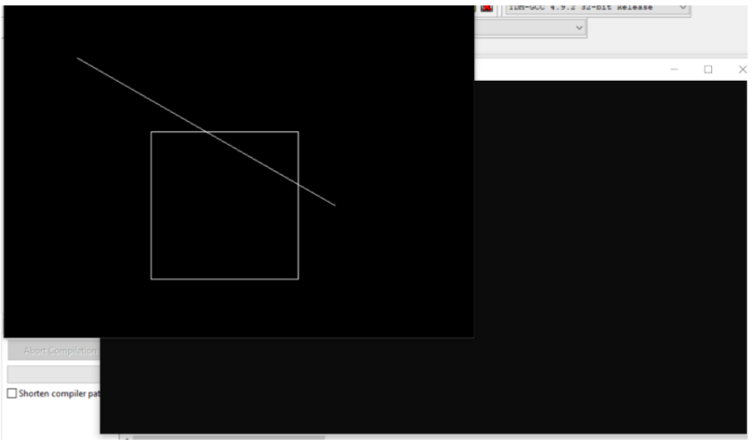
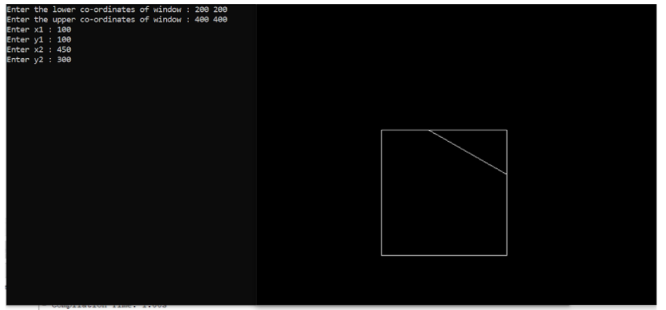

LEARNING OUTCOMES:
We got to know the implementation of Liang-Barsky line clipping algorithm using a C code.

EXPERIMENT 12

AIM: Write a Program to implement Rotation of an object.
THEORY:
A two-dimensional rotation is applied to an object by repositioning it along a circular path in the x-y plane. When we generate a rotation we get a rotation angle (θ) and the position about which the object is rotated (xr , yr). This is known as rotation point or pivot point.

The transformation can also be described as a rotation about the rotation axis that is perpendicular to the x-y plane and passes through the pivot point. Positive values for the rotation angle define counterclockwise rotations about the pivot point and the negative values rotate objects in the clockwise direction.

Types of Rotation:

- Anticlockwise
- Counterclockwise

The positive value of the pivot point (rotation angle) rotates an object in a counter-clockwise (anti-clockwise) direction.
The negative value of the pivot point (rotation angle) rotates an object in a clockwise direction.
When the object is rotated, then every point of the object is rotated by the same angle.
Straight Line: Straight Line is rotated by the endpoints with the same angle and redrawing the line between new endpoints.
Polygon: Polygon is rotated by shifting every vertex using the same rotational angle.
Curved Lines: Curved Lines are rotated by repositioning of all points and drawing of the curve at new positions.
Circle: It can be obtained by center position by the specified angle.
Ellipse: Its rotation can be obtained by rotating major and minor axis of an ellipse by the desired angle.

CODE:

#include<stdio.h>
#include<graphics.h>
#include<math.h>
main()
{
intgd=0,gm,x1,y1,x2,y2,x3,y3;
double s,c, angle;
initgraph(&gd, &gm, "C:\\TURBOC3\\BGI");
setcolor(RED);
printf("Enter coordinates of triangle: ");
scanf("%d%d%d%d%d%d",&x1,&y1,&x2,&y2, &x3, &y3);
setbkcolor(WHITE);
cleardevice();
line(x1,y1,x2,y2);
line(x2,y2, x3,y3);
line(x3, y3, x1, y1);
getch();
setbkcolor(BLACK);
printf("Enter rotation angle: ");
scanf("%lf", &angle);
setbkcolor(WHITE);
c = cos(angle *M_PI/180);
s = sin(angle *M_PI/180);
x1 = floor(x1 * c + y1 * s);
y1 = floor(-x1 * s + y1 * c);
x2 = floor(x2 * c + y2 * s);
y2 = floor(-x2 * s + y2 * c);
x3 = floor(x3 * c + y3 * s);
y3 = floor(-x3 * s + y3 * c);
cleardevice();
line(x1, y1 ,x2, y2);
line(x2,y2, x3,y3);
line(x3, y3, x1, y1);
getch();
closegraph();
return 0;
}
OUTPUT:
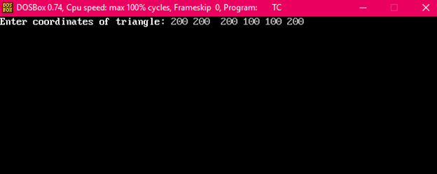
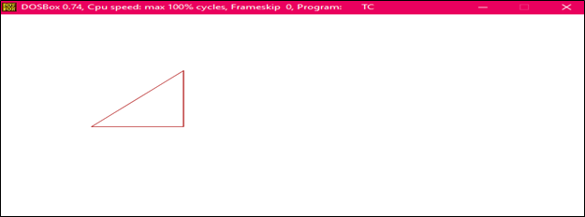
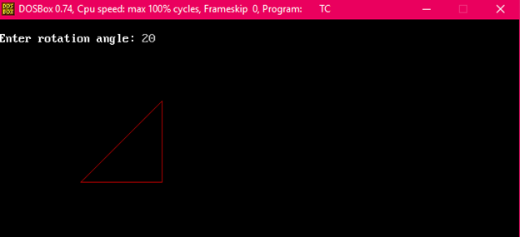
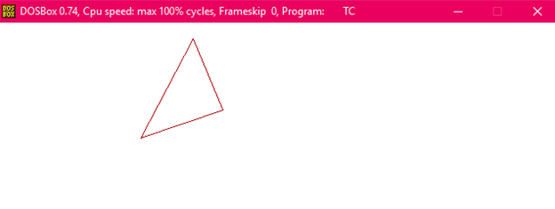
LEARNING OUTCOMES:
We got to know that how an object is rotated using C code.

EXPERIMENT 13

AIM: Write a Program to implement scaling an object.

THEORY:
A scaling transformation alters the size of an object. In the scaling process, we either compress or expand the dimension of the object.
Scaling operation can be achieved by multiplying each vertex coordinate (x, y) of the polygon by scaling factor sx and sy to produce the transformed coordinates as (x’, y’).
So, x’ = x * sx and y’ = y * sy.

Scaling is done by multiplying the given object matrix with the scaling transformation matrix, to obtain the new image of the required size.
The program prompts the user for the number of vertices in the polygon and takes their vertex coordinates in a cyclic order. It then asks the user to form x-scale factor and y-scale factor.
The user is expected to enter the number of times to scale the given object in the respective direction.
The final image of the scaled object along with the original object is drawn.

CODE:
#include<iostream.h>
#include<graphics.h>
#include<math.h>
#include<conio.h>
#include<dos.h>

void mul(int mat[3][3],int vertex[10][3],int n);
void scale(int vertex[10][3],int n);
void init(int vertex[10][3],int n);

int main()
{
int i,x,y;
int vertex[10][3],n;

clrscr();

cout<<"\nEnter the no. of vertex : ";
cin>>n;
for(i=0;i<n;i++)
{
cout<<"Enter the points (x,y): ";
cin>>x>>y;
vertex[i][0]=x;
vertex[i][1]=y;
vertex[i][2]=1;
}
scale(vertex,n);

getch();
return 0;
}

void init(int vertex[10][3],int n)
{
int gd=DETECT,gm,i;
initgraph(&gd,&gm,"C:\\turboc3\\bgi");

setcolor(10);
line(0,240,640,240); //drawing X axis
line(320,0,320,480); //drawing Y axis

setcolor(3);
line(450,20,490,20);
setcolor(15);
line(450,50,490,50);
setcolor(6);
outtextxy(500,20,"Original");
outtextxy(500,50,"Transformed");

setcolor(3);

for(i=0;i<n-1;i++)
{
line(320+vertex[i][0],240-vertex[i][1],320+vertex[i+1][0],240-vertex[i+1][1]);
}
line(320+vertex[n-1][0],240-vertex[n-1][1],320+vertex[0][0],240-vertex[0][1]);

}

void mul(int mat[3][3],int vertex[10][3],int n)
{
int i,j,k; // loop variables

int res[10][3];

for(i=0;i<n;i++)
{
for(j=0;j<3;j++)
{
res[i][j]=0;
for(k=0;k<3;k++)
{
res[i][j] = res[i][j] + vertex[i][k]*mat[k][j];
}
}
}

setcolor(15);
for(i=0;i<n-1;i++)
{
line(320+res[i][0],240-res[i][1],320+res[i+1][0],240-res[i+1][1]);
}
line(320+res[n-1][0],240-res[n-1][1],320+res[0][0],240-res[0][1]);

}

void scale(int vertex[10][3],int n)
{
//scaling transformation matrix
int scale_array[3][3];

int x,y;

//taking user input for shear direction
cout<<"\nEnter scale factor in X direction: ";
cin>>x;
cout<<"Enter scale factor in Y direction: ";
cin>>y;

scale_array[0][0]=x;
scale_array[1][0]=0;
scale_array[2][0]=0;
scale_array[0][1]=0;
scale_array[1][1]=y;
scale_array[2][1]=0;
scale_array[0][2]=0;
scale_array[1][2]=0;
scale_array[2][2]=1;
init(vertex,n);
mul(scale_array,vertex,n);
}

OUTPUT:
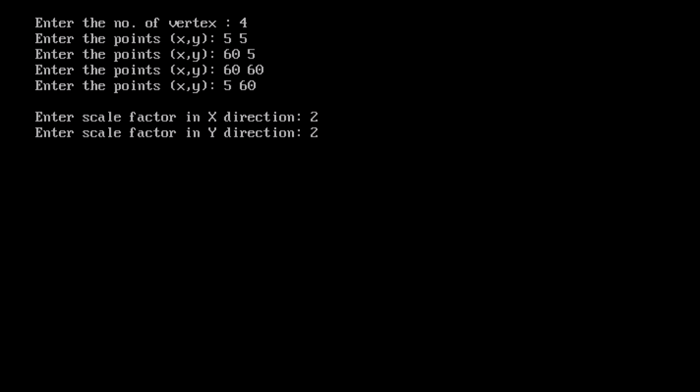

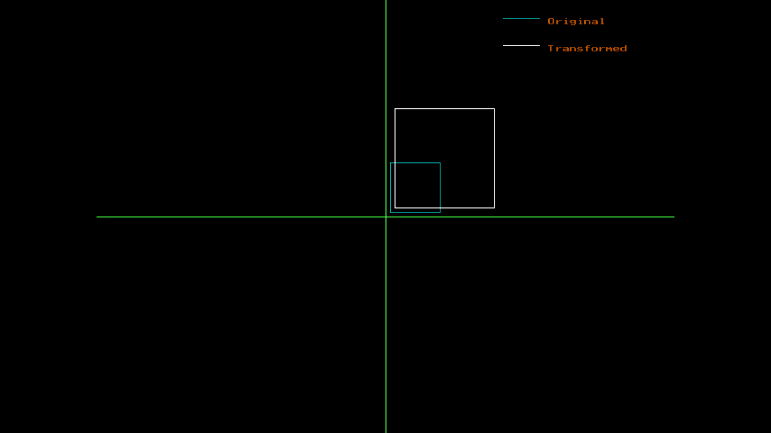

LEARNING OUTCOMES:
Through this, we got to know that how an object is scaled using C code.

